SIMPLE HTML WEBSITE WITH CI/CD PIPELINE SCENARIO

Micro Project Report

Submitted by

NAVAJEEVAN K S 23ITR109

Course Code & Name : 22CDF03-DEVOPS
Programme & Branch : B.TECH - IT
Department : Information Technology

Kongu Engineering College, Perundurai
April 2026

BONAFIDE CERTIFICATE

Certified that this micro project documentation of “ SIMPLE HTML WEBSITE WITH CI/CD PIPELINE SCENARIO” is the bonafide work of “NAVAJEEVAN K S (22ITR109)” who carried out the project under my supervision. Certified further that to the best of my knowledge the work reported here in does not form part of my other thesis or dissertation on the basis of which a degree or awarded was conferred on an earlier occasion on this or any other candidate.

Submitted on 07.05.25

SIGNATURE | SIGNATURE
DR P A SELVARAJ  MCA., MPhil., ME., Ph.D., | Dr. R.THANGARAJAN,  B.E.,M.E.,Ph.D
SUPERVISOR | HEAD OF THE DEPARTMENT
Assistant Professor | Professor & HOD,
Department of CSD, | Department of CSD,
Kongu Engineering College,  Perundurai | Kongu Engineering College,  Perundurai

AIM

The main aim of this project is to study and implement Continuous Integration and Continuous Deployment (CI/CD) concepts using Jenkins in a practical environment.

In this project, we aim to develop a simple static HTML website and host the source code on GitHub. The objective is to automate the process of building and deploying the website whenever changes are made to the code.

Another important aim is to configure a Jenkins pipeline that integrates with GitHub using webhooks, enabling automatic triggering of build and deployment processes on every code push.

This project also helps in understanding how modern software delivery is automated using CI/CD pipelines, reducing manual effort and ensuring faster and reliable deployment of applications.

ABSTRACT

This project focuses on implementing Continuous Integration and Continuous Deployment (CI/CD) for a static HTML website using Jenkins. The source code of the website is maintained in a GitHub repository, enabling version control and easy collaboration. Jenkins is configured to automatically fetch the latest code whenever changes are pushed to the repository. The pipeline includes stages such as code retrieval, build (if required), and deployment to a web server. Apache is used as the hosting server to serve the deployed website. GitHub webhooks are integrated with Jenkins to trigger the pipeline automatically on each code update. This automation reduces manual intervention and ensures faster, reliable, and consistent deployment. The project demonstrates how modern DevOps practices can be applied to simplify and streamline the software delivery process.

SCOPE & OBJECTIVES

Scope:

The scope of this project is focused on implementing Continuous Integration and Continuous Deployment (CI/CD) for a static HTML website using Jenkins.

• Hosting source code on GitHub for version control
• Configuring Jenkins pipeline for automated build and deployment
• Integrating GitHub webhooks to trigger builds automatically
• Deploying the website to a web server (Apache)
• Managing code updates and ensuring continuous delivery

This project can be further enhanced by adding automated testing, Docker-based containerization, and deploying applications on cloud platforms like AWS. It can also be extended with monitoring tools and dynamic UI development using JavaScript or backend technologies.

Objectives:

The main objectives of this project are:
• To understand the concepts of Continuous Integration and Continuous Deployment (CI/CD)
• To develop a static HTML website and manage its code using GitHub
• To configure Jenkins for automating build and deployment processes
• To integrate GitHub with Jenkins using webhooks for automatic triggering
• To deploy the website on a web server (Apache) and verify continuous delivery

HARDWARE & SOFTWARE REQUIREMENTS

Hardware Requirements:

The project does not require high-end hardware. A standard system is sufficient:

Processor: Intel i5 or equivalent

RAM: Minimum 8GB

Storage: At least 20GB free space

Internet connection for installing packages

Software Requirements:

The following software tools are required:
• Git – for version control and managing source code
• GitHub – to host the repository and manage code changes
• Jenkins – to implement CI/CD pipeline automation
• Apache (Apache2) – to host and serve the static HTML website
• Java (OpenJDK) – required to run Jenkins
• VS Code – for writing and editing code
• Browser – to access Jenkins dashboard and view the deployed website

PROJECT DESIGN

The system is divided into three main parts:

1. GitHub Repository:

The source code of the HTML website is stored in GitHub:
• Contains all website files (HTML, CSS)
• Maintains version control for code changes
• Triggers Jenkins automatically using webhooks

2. Jenkins Pipeline:

Jenkins acts as the automation server:
• Fetches latest code from GitHub
• Executes pipeline stages (Clone, Build, Deploy)
• Automates the deployment process
• Ensures continuous integration and delivery

3. Web Server (Apache):

Apache is used to host the website:
• Receives files from Jenkins deployment
• Stores files in /var/www/html
• Serves the website to users via browser

Working Flow:

Developer pushes code to GitHub

GitHub webhook triggers Jenkins

Jenkins runs pipeline and deploys files

Apache server updates and displays website

This design is simple but very effective for learning purposes.

ADVANTAGES

This project provides several advantages:

• Automates the build and deployment process, reducing manual effort
• Enables faster and continuous delivery of updates
• Minimizes human errors through automation
• Improves productivity and efficiency in development
• Ensures consistent and reliable deployment
• Easy to integrate with tools like GitHub and Apache
• Supports scalability and modern DevOps practices

It also helps students understand real-world application deployment.

PROPOSED SYSTEM

The proposed system is designed to overcome the limitations of traditional manual deployment methods.Instead of manually updating and deploying the website, this system automates the entire process using CI/CD.

Features of Proposed System:

Automated build and deployment using Jenkins

Integration with GitHub for version control

Webhook-based triggering for real-time updates

Continuous delivery of website to Apache server

Reduced manual intervention and faster deployment

The system ensures that even if one container fails, others are not affected.

IMPLEMENTATION OF THE PROJECT

The implementation is done step by step:
Step 1: Setup Environment
• Install Git, Java (OpenJDK), Jenkins, and Apache
• Install required plugins in Jenkins (Git, Pipeline)
Step 2: Create GitHub Repository
• Create a repository and upload HTML project files
• Maintain code using version control
Step 3: Configure Jenkins
• Create a new pipeline job
• Connect Jenkins with GitHub repository
• Configure Git tool and credentials
Step 4: Create Jenkins Pipeline
• Add Jenkinsfile with stages (Clone, Build, Deploy)
• Configure deployment path /var/www/html/
Step 5: Setup Webhook
• Add GitHub webhook to trigger Jenkins automatically
• Enable “GitHub hook trigger” in Jenkins
Step 6: Deployment
• Push code to GitHub
• Jenkins automatically clones and deploys files to Apache
Step 7: Testing
• Verify Jenkins build success
• Open browser and check website using public IP
• Confirm automatic updates on each code push
Challenges Faced
• Configuring Jenkins and integrating it with GitHub webhooks can be complex for beginners
• Managing permissions while deploying files to the Apache server may cause errors

OUTPUT SCREENSHOTS

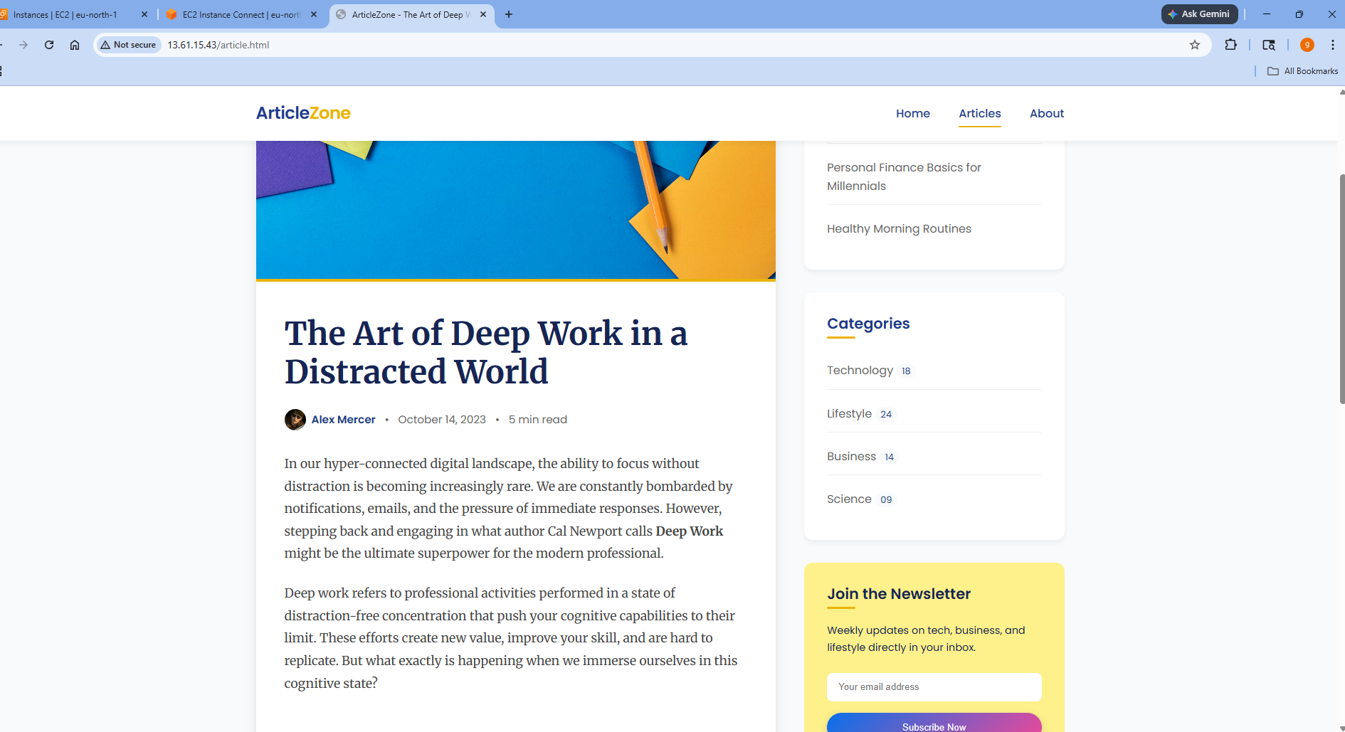

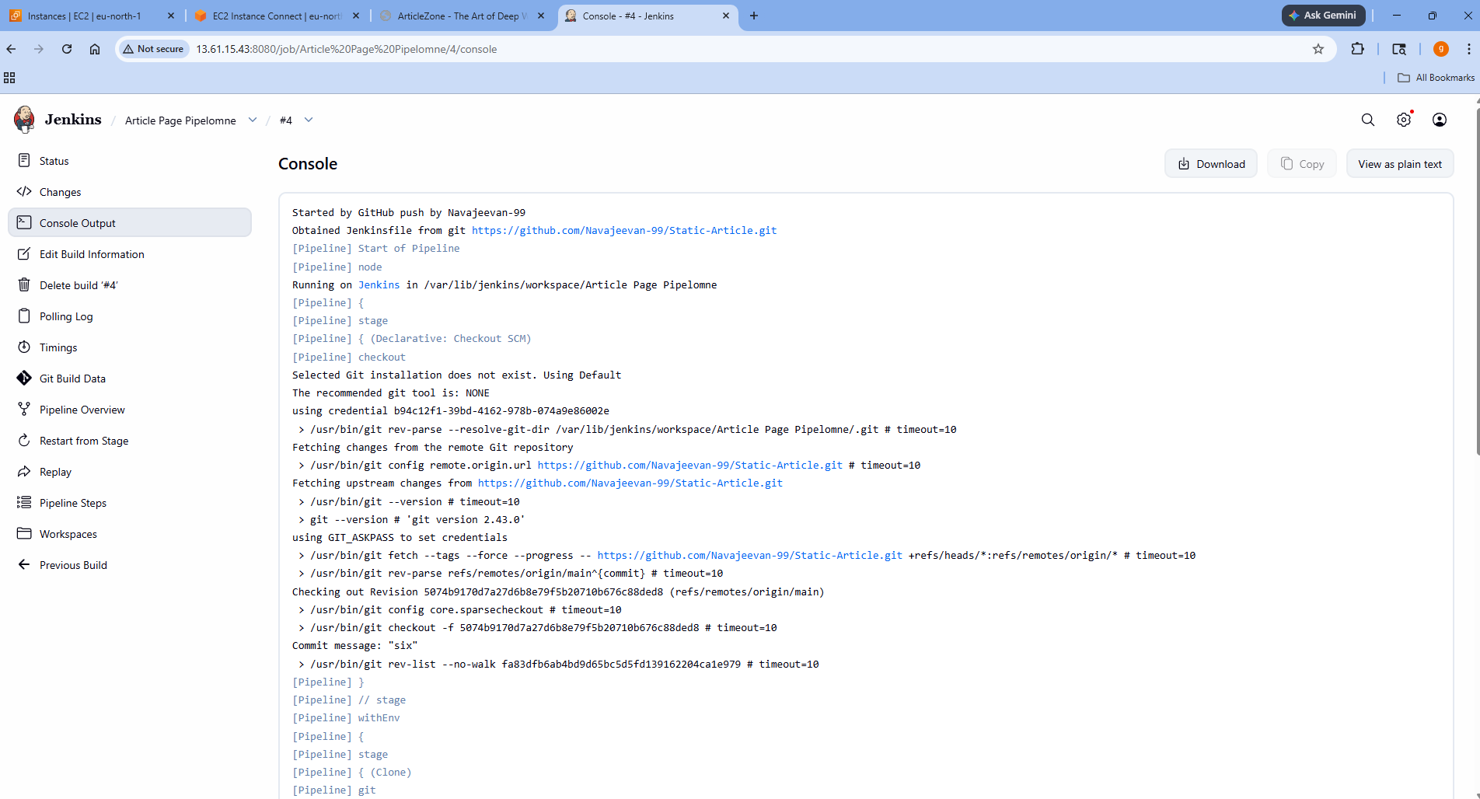

CONCLUSION

This project successfully demonstrates the implementation of CI/CD using Jenkins for a static HTML website. It automates the process of building and deploying code from GitHub to a web server. The use of webhooks ensures real-time updates without manual intervention. The system improves efficiency, reliability, and speed of deployment. Overall, it highlights the importance of DevOps practices in modern software development.

CODING / COMMANDS

CODING:

Jenkins File

pipeline{
agent any
stages{
stage('Clone') {
steps {
git branch: 'main', url: 'https://github.com/Navajeevan-99/Static-Article.git'}}
stage('Deploy') {
steps {
sh 'cp -r * /var/www/html/' }}}}

index.html:

<!DOCTYPE html>
<html lang="en">
<head>
<meta charset="UTF-8">
<meta name="viewport" content="width=device-width, initial-scale=1.0">
<title>ArticleZone - Home</title>
<link rel="stylesheet" href="style.css">
</head>
<body>
<header>
<div class="header-container">
<a href="index.html" class="site-title">
Article<span>Zone</span>
</a>
<nav>
<ul>
<li><a href="index.html" class="active">Home</a></li>
<li><a href="article.html">Articles</a></li>
<li><a href="about.html">About</a></li>
</ul>
</nav>
</div>
</header>

<main class="container">
<!-- Feed Section -->
<section class="home-feed">
<div class="welcome-banner">
<h1>Welcome to ArticleZone</h1>
<p>Your source for insightful articles spanning technology, business, lifestyle, and science.</p>
</div>

<article class="post-card">
<a href="article.html">
<img src="https://images.unsplash.com/photo-1510070112810-d4e9a46d9e91?q=80&w=2000&auto=format&fit=crop" alt="Person typing on laptop">
</a>
<div class="post-content">
<div class="article-meta" style="margin-bottom: 1rem;">
<span>October 14, 2023</span><span>•</span><span>Productivity</span>
</div>
<h2><a href="article.html">The Art of Deep Work in a Distracted World</a></h2>
<p class="post-excerpt">In our hyper-connected digital landscape, the ability to focus without distraction is becoming increasingly rare. Learn how to cultivate deep work habits that will significantly boost your productivity.</p>
<a href="article.html" class="btn-read-more" style="margin-top: 0.5rem; border-radius: 8px;">Read Article →</a>
</div>
</article>

<article class="post-card">
<a href="article.html">
<img src="https://images.unsplash.com/photo-1451187580459-43490279c0fa?q=80&w=2000&auto=format&fit=crop" alt="Abstract technology network">
</a>
<div class="post-content">
<div class="article-meta" style="margin-bottom: 1rem;">
<span>September 28, 2023</span><span>•</span><span>Technology</span>
</div>
<h2><a href="article.html">10 Emerging Tech Trends for 2024</a></h2>
<p class="post-excerpt">From generative AI to quantum computing, the technological landscape is shifting faster than ever. Explore the top ten trends that are poised to reshape industries in the coming year.</p>
<a href="article.html" class="btn-read-more" style="margin-top: 0.5rem; border-radius: 8px;">Read Article →</a>
</div>
</article>
</section>

<!-- Sidebar Section -->
<aside>
<div class="widget">
<h3>Recent Posts</h3>
<ul>
<li><a href="article.html">The Art of Deep Work</a></li>
<li><a href="article.html">10 Emerging Tech Trends for 2024</a></li>
<li><a href="#">The Evolution of Minimalist Design</a></li>
<li><a href="#">Personal Finance Basics for Millennials</a></li>
<li><a href="#">Healthy Morning Routines</a></li>
</ul>
</div>
<div class="widget">
<h3>Categories</h3>
<ul>
<li><a href="#" class="category-item"><span>Technology</span> <span class="badge">18</span></a></li>
<li><a href="#" class="category-item"><span>Lifestyle</span> <span class="badge">24</span></a></li>
<li><a href="#" class="category-item"><span>Business</span> <span class="badge">14</span></a></li>
<li><a href="#" class="category-item"><span>Science</span> <span class="badge">09</span></a></li>
</ul>
</div>
<div class="widget" style="background-color: var(--secondary-light); box-shadow: none;">
<h3 style="color: var(--primary-dark);">Join the Newsletter</h3>
<p style="color: var(--primary-dark); font-size: 0.9rem; margin-bottom: 1.5rem;">Weekly updates on tech, business, and lifestyle directly in your inbox.</p>
<input type="email" placeholder="Your email address" style="width: 100%; padding: 0.8rem 1rem; border: none; border-radius: 8px; margin-bottom: 1rem; outline: none;">
<button class="btn-read-more" style="width: 100%; margin-top: 0;">Subscribe Now</button>
</div>
</aside>
</main>

<footer>
<div class="footer-content">
<div class="footer-brand">
<h2>ArticleZone</h2>
<p>Dedicated to bringing you the best carefully curated insights across a diverse range of topics.</p>
</div>
<div class="social-links">
<!-- Keep SVG icons identical -->
<a href="#" aria-label="Twitter"><svg width="20" height="20" fill="currentColor" viewBox="0 0 24 24"><path d="M24 4.557c-.883.392-1.832.656-2.828.775 1.017-.609 1.798-1.574 2.165-2.724-.951.564-2.005.974-3.127 1.195-.897-.957-2.178-1.555-3.594-1.555-3.179 0-5.515 2.966-4.797 6.045-4.091-.205-7.719-2.165-10.148-5.144-1.29 2.213-.669 5.108 1.523 6.574-.806-.026-1.566-.247-2.229-.616-.054 2.281 1.581 4.415 3.949 4.89-.693.188-1.452.232-2.224.084.626 1.956 2.444 3.379 4.6 3.419-2.07 1.623-4.678 2.348-7.29 2.04 2.179 1.397 4.768 2.212 7.548 2.212 9.142 0 14.307-7.721 13.995-14.646.962-.695 1.797-1.562 2.457-2.549z"/></svg></a>
<a href="#" aria-label="Facebook"><svg width="20" height="20" fill="currentColor" viewBox="0 0 24 24"><path d="M9 8h-3v4h3v12h5v-12h3.642l.358-4h-4v-1.667c0-.955.192-1.333 1.115-1.333h2.885v-5h-3.808c-3.596 0-5.192 1.583-5.192 4.615v3.385z"/></svg></a>
<a href="#" aria-label="Instagram"><svg width="20" height="20" fill="currentColor" viewBox="0 0 24 24"><path d="M12 2.163c3.204 0 3.584.012 4.85.07 3.252.148 4.771 1.691 4.919 4.919.058 1.265.069 1.645.069 4.849 0 3.205-.012 3.584-.069 4.849-.149 3.225-1.664 4.771-4.919 4.919-1.266.058-1.644.07-4.85.07-3.204 0-3.584-.012-4.849-.07-3.26-.149-4.771-1.699-4.919-4.92-.058-1.265-.07-1.644-.07-4.849 0-3.204.013-3.583.07-4.849.149-3.227 1.664-4.771 4.919-4.919 1.266-.057 1.645-.069 4.849-.069zm0-2.163c-3.259 0-3.667.014-4.947.072-4.358.2-6.78 2.618-6.98 6.98-.059 1.281-.073 1.689-.073 4.948 0 3.259.014 3.668.072 4.948.2 4.358 2.618 6.78 6.98 6.98 1.281.058 1.689.072 4.948.072 3.259 0 3.668-.014 4.948-.072 4.354-.2 6.782-2.618 6.979-6.98.059-1.28.073-1.689.073-4.948 0-3.259-.014-3.667-.072-4.947-.196-4.354-2.617-6.78-6.979-6.98-1.281-.059-1.69-.073-4.949-.073zm0 5.838c-3.403 0-6.162 2.759-6.162 6.162s2.759 6.163 6.162 6.163 6.162-2.759 6.162-6.163c0-3.403-2.759-6.162-6.162-6.162zm0 10.162c-2.209 0-4-1.79-4-4 0-2.209 1.791-4 4-4s4 1.791 4 4c0 2.21-1.791 4-4 4zm6.406-11.845c-.796 0-1.441.645-1.441 1.44s.645 1.44 1.441 1.44c.795 0 1.439-.645 1.439-1.44s-.644-1.44-1.439-1.44z"/></svg></a>
</div>
</div>
<div class="copyright">&copy; 2023 ArticleZone. All rights reserved.</div>
</footer>
</body>
</html>

COMMANDS:

Git Commands:
git init
git add .
git commit -m "initial commit"
git push origin main
git pull origin main
Jenkins Commands:
sudo systemctl start jenkins
sudo systemctl stop jenkins
sudo systemctl restart jenkins
sudo systemctl status jenkins
Apache Commands:

sudo systemctl start apache2
sudo systemctl stop apache2
sudo systemctl restart apache2
sudo systemctl status apache2

Deployment Commands:

cp -r * /var/www/html/
ls /var/www/html/
cat /var/www/html/index.html

Mastering DevOps course completion certificate

